Locking clip missing

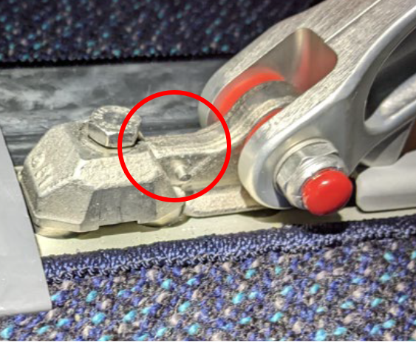

Seat fitting and clip not engaged in seat track

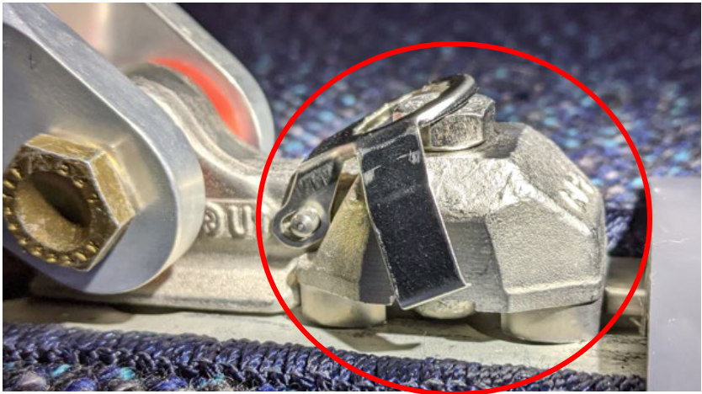

Seat fitting and clip correctly installed in seat track

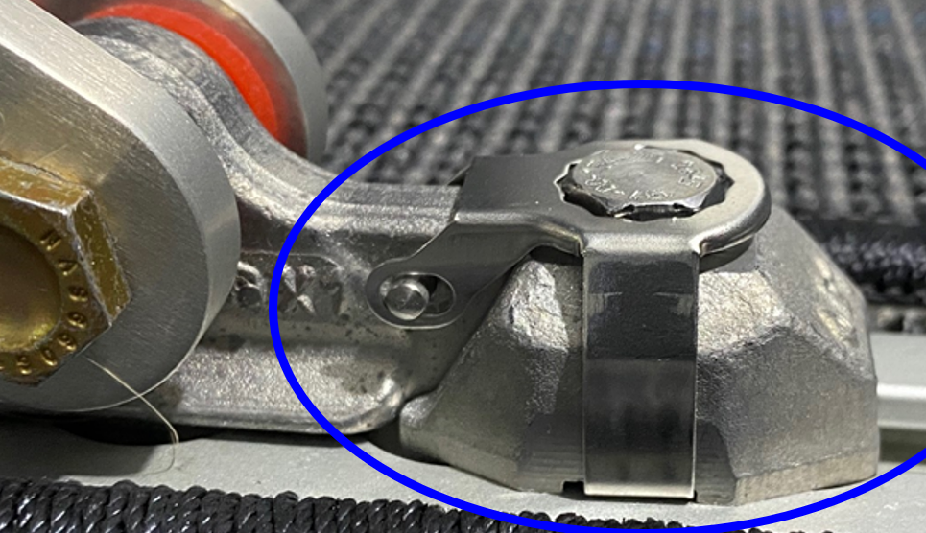

Seat track fitting examples:

Reference Only

